Login to TSOJ1 Region –
- Type ‘M’ to select ASIM/INFO on command line in ISPF primary panel
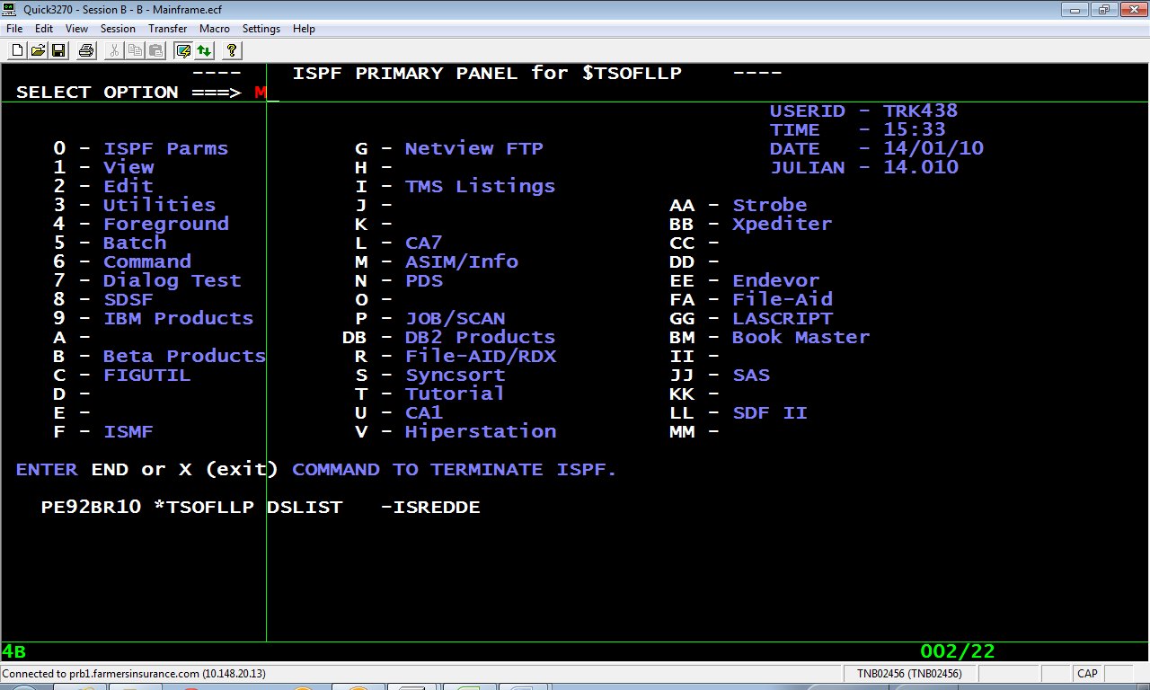
- Option 1 ( Prod )
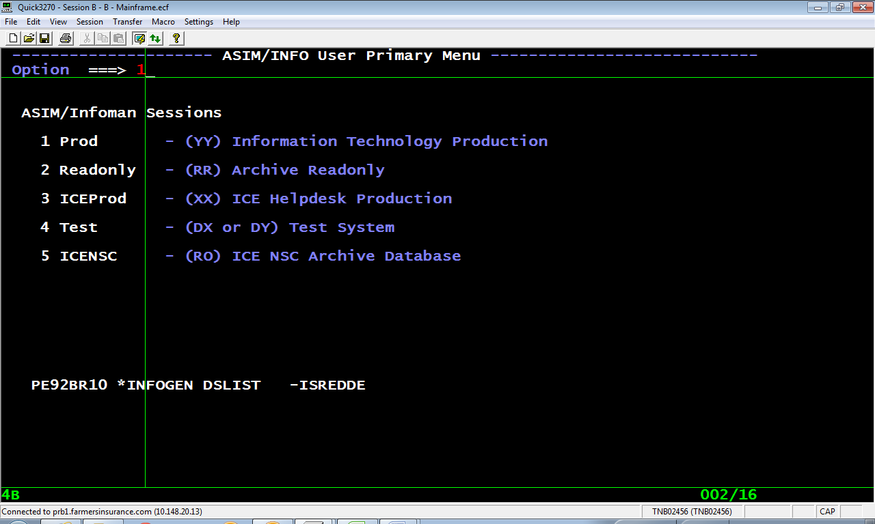
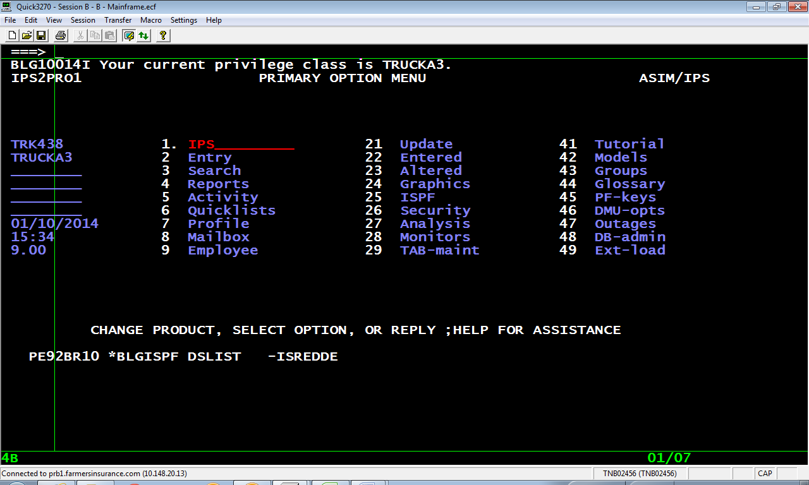
- To copy the previous RFS give command as below – ( COPY R rfs#)
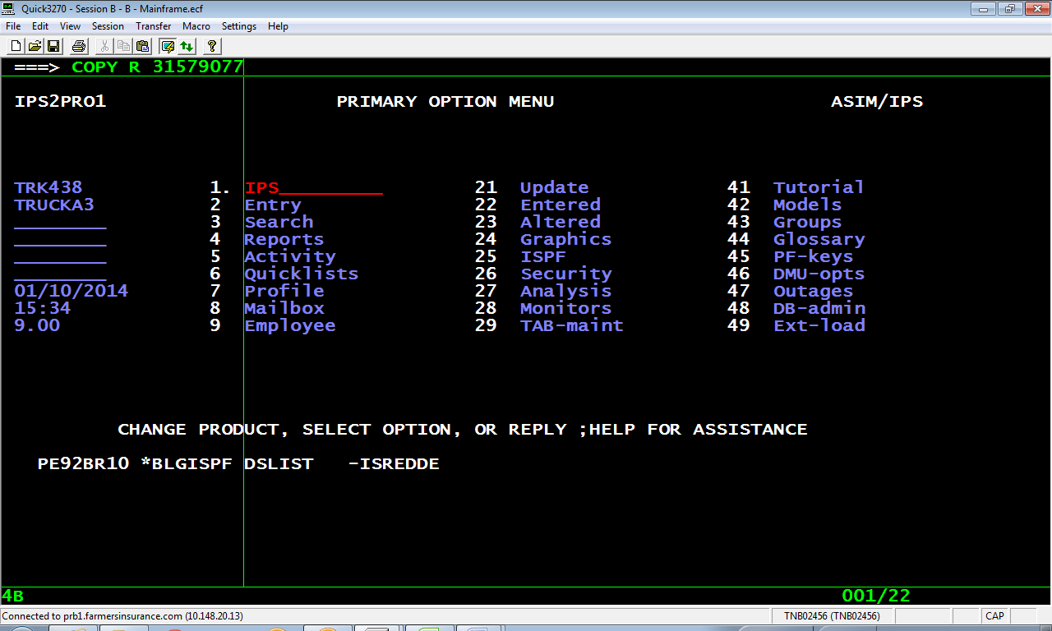

- Update the relevant details in the below screen ( Name,Date required etc..)
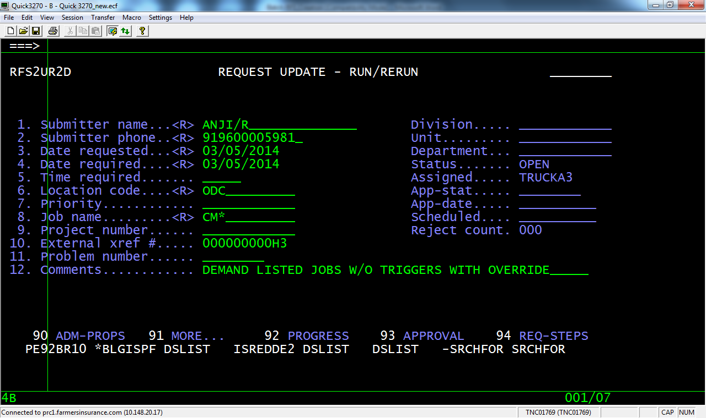
- The below screen will come once we press enter after filling the required details. We need to update the purpose/Reason of this RFS under comments.
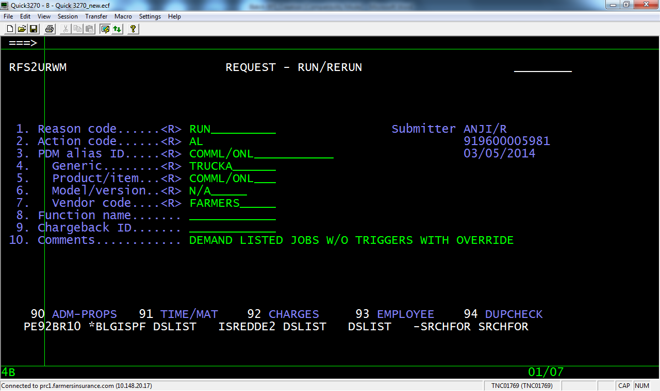
- The below screen will come once we press enter after filling the required details -
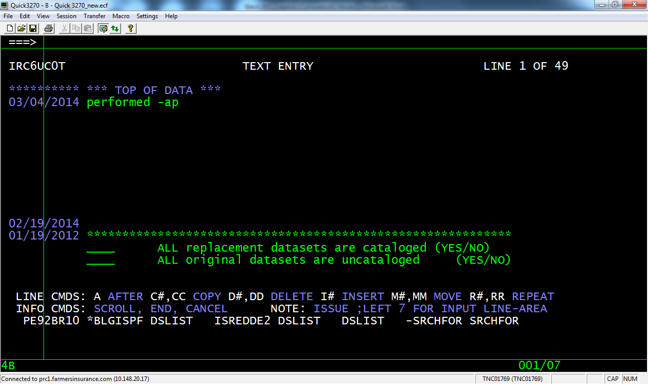
- Remove comments (Generally first line under “****TOP OF DATA****” ) entered by operations/Scheduling team for Previous RFS . Press F10 which will allow us to delete the comments.
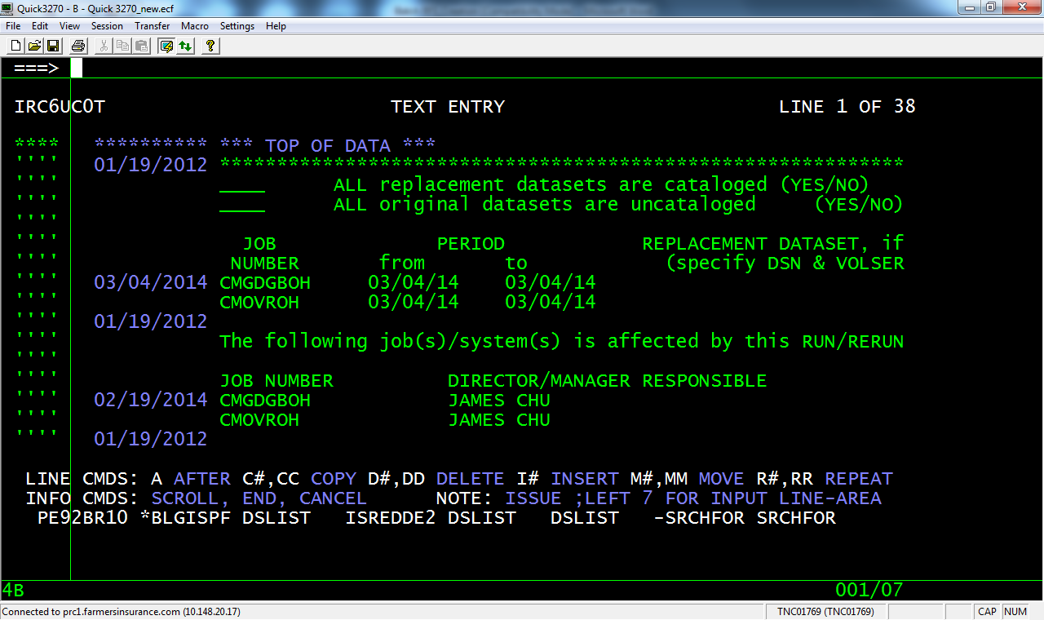

- Update Job name under ‘JOB NUMBER’ and date under ‘PERIOD’ accurately. Director/Manager Responsible name should be mentioned as Plaban Mohapatra.
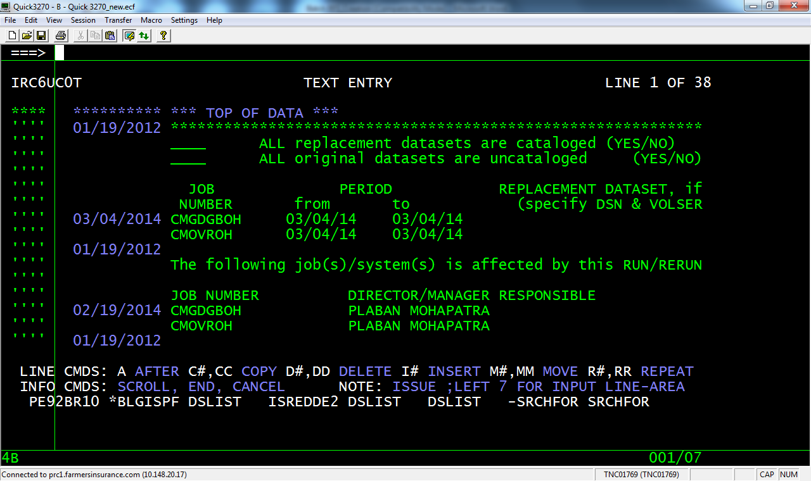
- We need to provide proper instructions under SPECIAL INSTRUCTIONS section. E.g. Which job need to run , with or w/o triggers, with override or from prod , with or w/o hold, location (ODC/LA), date etc.. THIS IS MOST IMPORTANT SECTION OF RFS AND PLEASE DOUBLE CHECK.
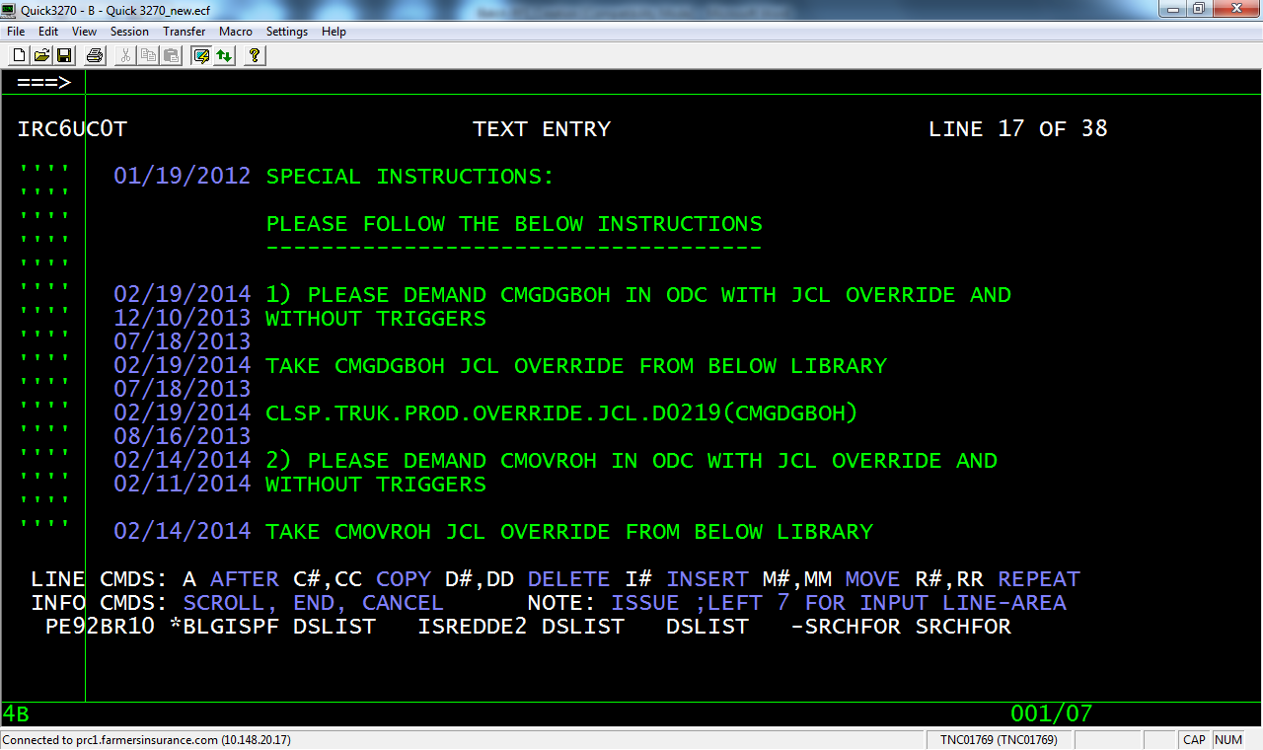
- Update proper reason with defect number in ‘REASON FOR REQUEST’ section.
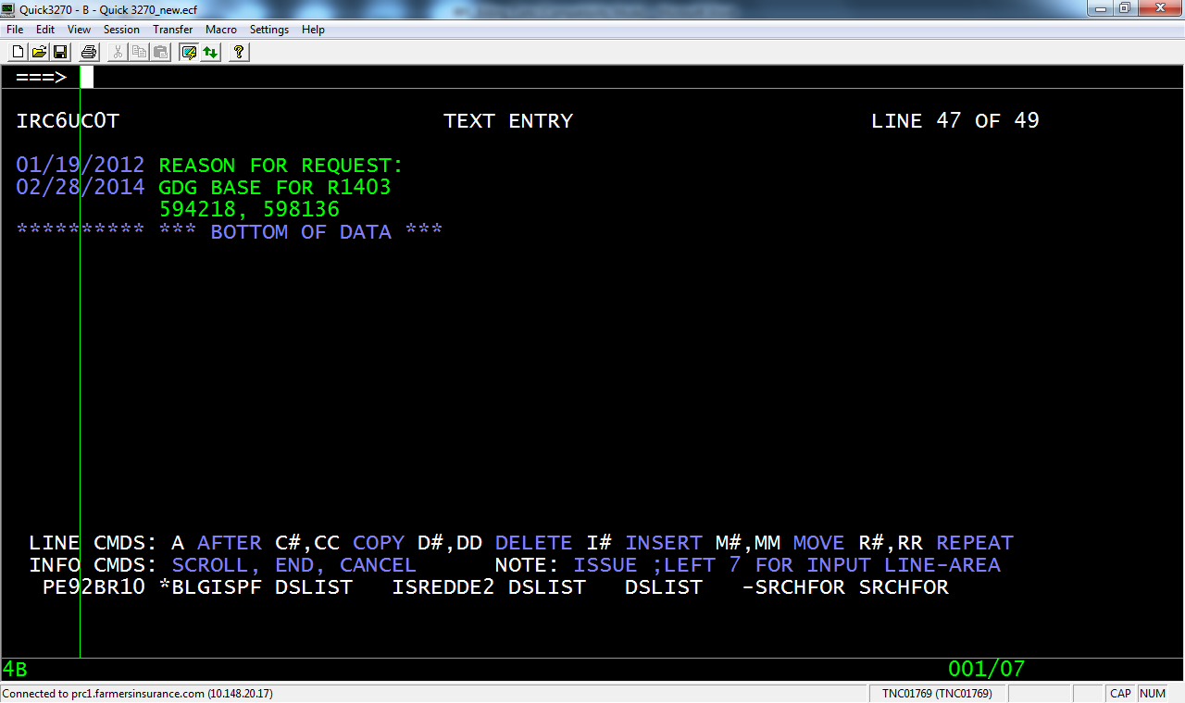
- Verify (double check) all the above setions in 98 option for accuaracy and press F3 to come back to main screen.
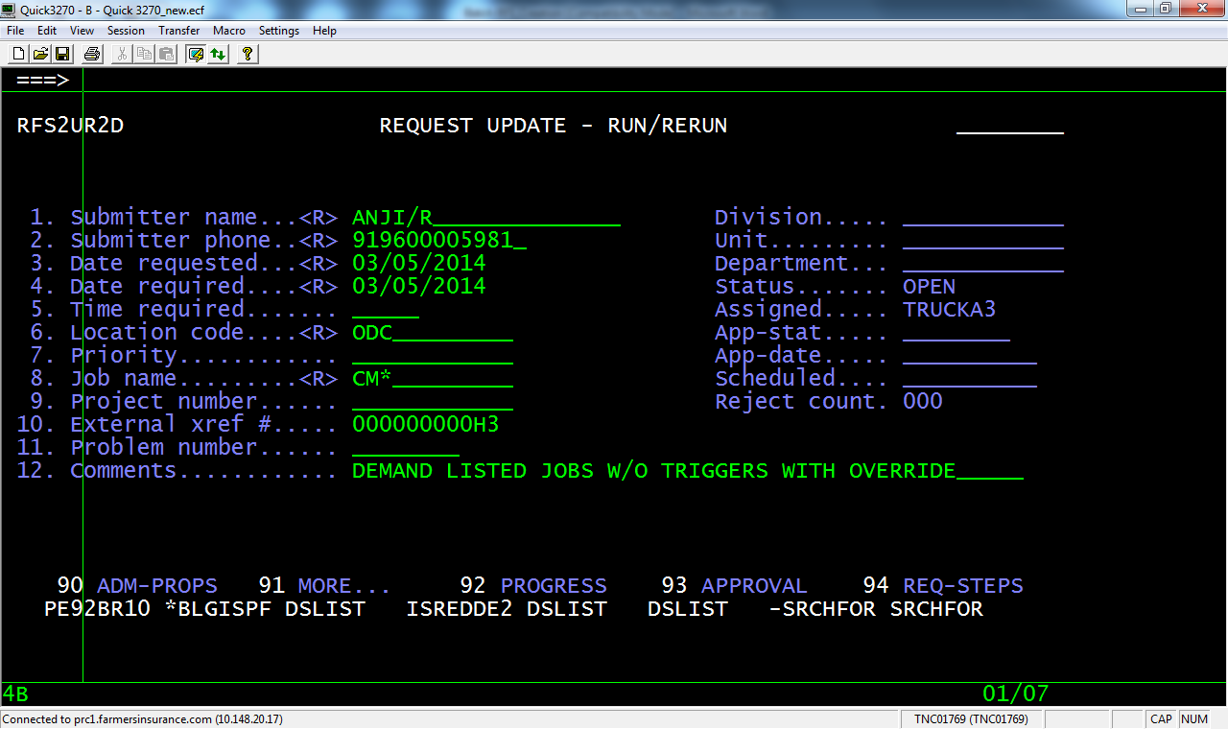
- Select 93 to update approval groups. TRUCKA2 & SETUP2 for Batch RFS.
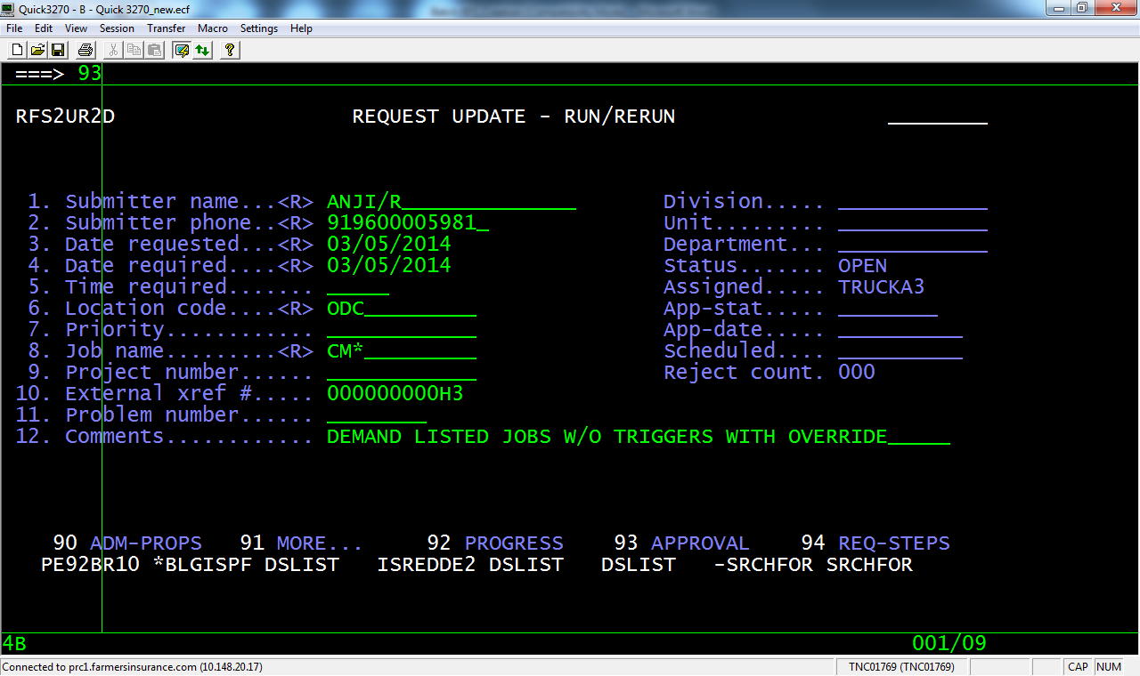

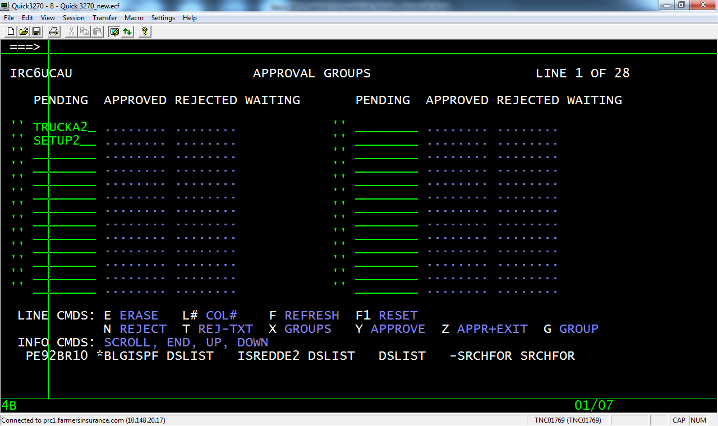
- Press Enter and then F3 to come back to main screen. Select 92.
We can edit the RFS later if we assign to TRUCKA3.
Please verify the RFS details ( 91,98,93 options ) for accuracy. Once confirmed that RFS is ready to process then pls assign to SETUP2 for batch RFS.
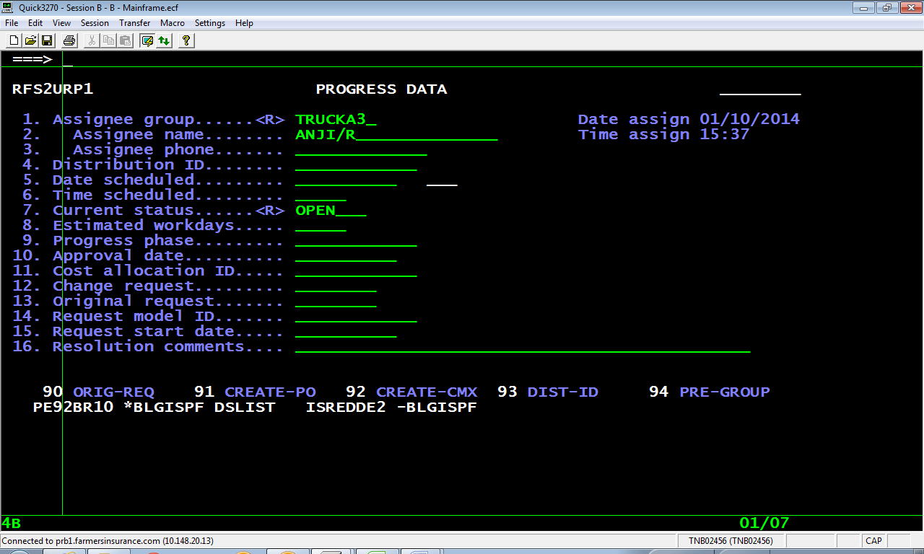
- Make changes below – just put assignee group and press enter it will show Assignee name and phone number
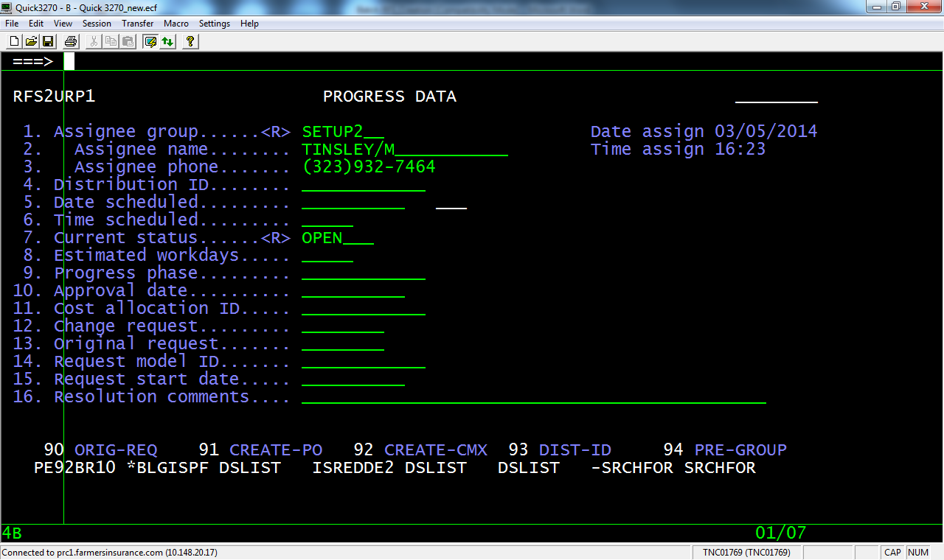
- Press Enter 2 times to come abck to main screen.
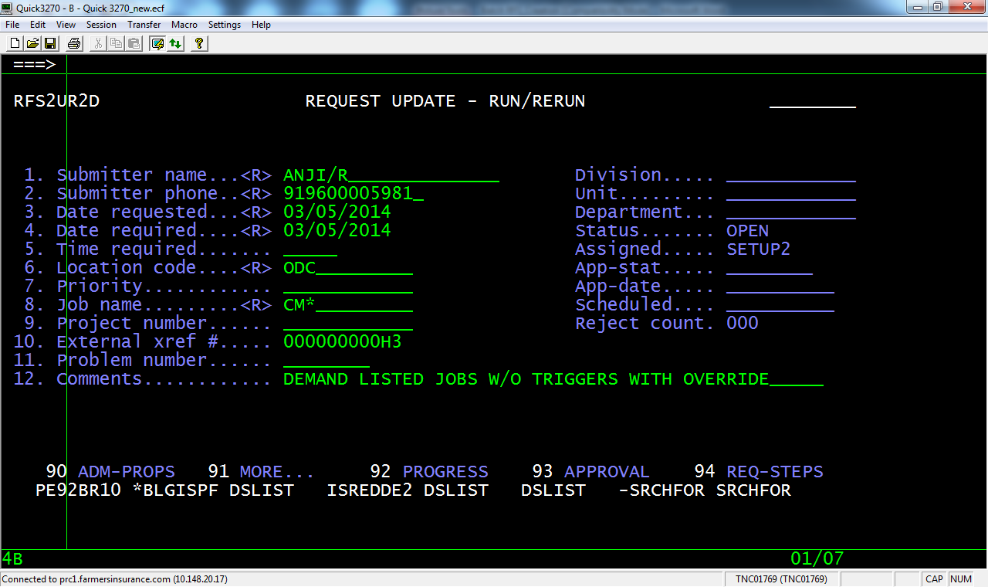
- Press F3. RFS created – Note down the RFS number
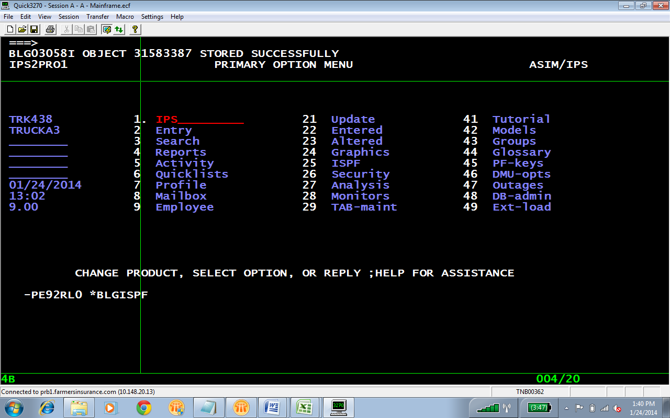

Updating the RFS -
- Command UPD R as below
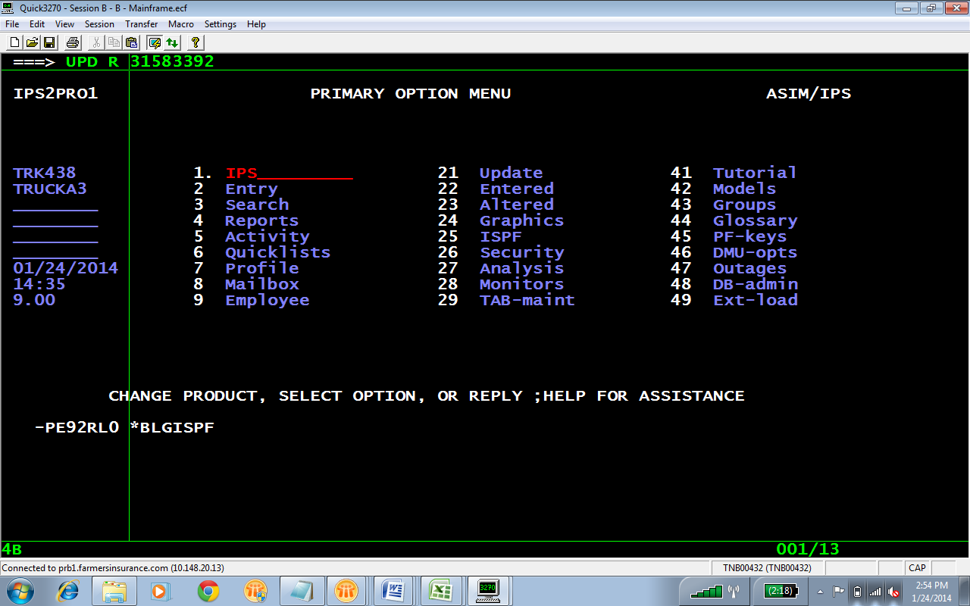
- To see RFS created by a person – Command is “SE PERS/NAME”. Name in this command should be same as the name given in RFS.
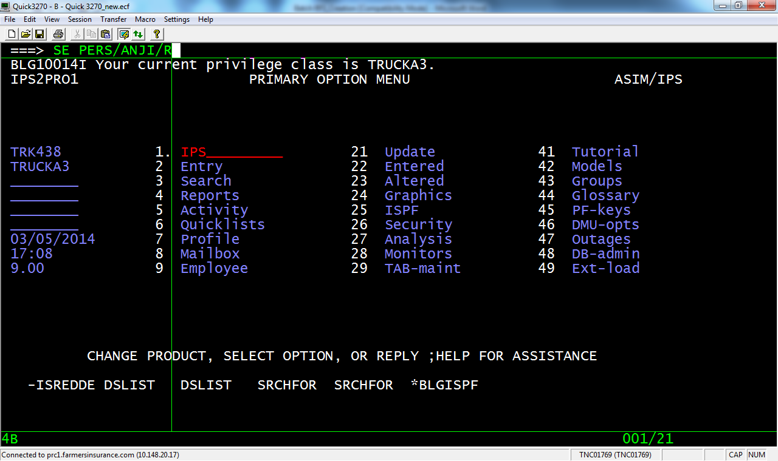
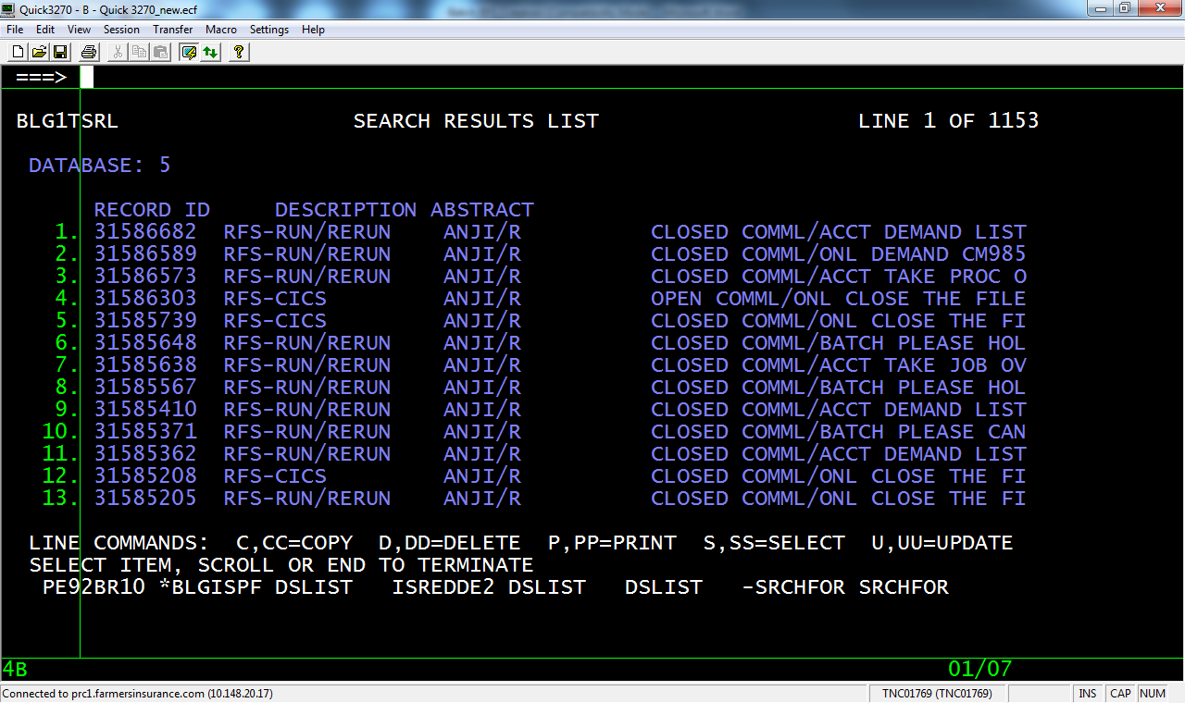
- To display the RFS -
